

**Subject:**

* Digital Logic Design (DLD)

**Instructor Name:**

* Shakir-Ullah Shah

**Project Name:**

* Tasbih Counter

**Group Members:**

* Jawad Ahmed (20P-0165)
* Hasnain Aleem (20P-0584)

**Simulator Name:**

* Proteus

**Simulator Download Link:**

* **Download Link:** [**Download Proteus**](https://bit.ly/36vAR93)

**Project Download Link:**

* **Download Link:** [**GOOGLE DRIVE LINK**](https://bit.ly/36vAxXT)

________________________________________________

**Project Explanation:**

In the project we made the tasbeh counter. In this we have used two Decade Synchronous Counter both the counter give output up-to nine. There are eight flip-flops in the Tasbeh Counter. The first Flip-Flop will go up-to the nine when the first flip-flop reaches up to nine the first flip-flop will recycle and the second flip-flop will run one time. Same as when the first flip-flop reaches to nine then the second flip-flop run one time when the first flip-flop generate the binary value of nine. The Tasbeh counter will run up to ninety-nine and at ninety-nine it will recyle and both the segment will be zero and the Tasbeh counter will start again.

**TIDS AND BITS OF PROJECT:**

* **Analysis:**

In the Tasbeh Counter we have used two synchronous Decade Counters. We have used 4 input And gate that will give high input if all input are high. When Q1 and Q2 low and Q3 and Q0 are high the second flip flop will produce output.

* **Truth Table:**

|  |  |  |  |  |
| --- | --- | --- | --- | --- |
| **Button** | **Q0** | **Q1** | **Q2** | **Q3** |
| 0 | 0 | 0 | 0 | 0 |
| 1 | 0 | 0 | 0 | 1 |
| 1 | 0 | 0 | 1 | 0 |
| 1 | 0 | 0 | 1 | 1 |
| 1 | 0 | 1 | 0 | 0 |
| 1 | 0 | 1 | 0 | 1 |
| 1 | 0 | 1 | 1 | 0 |
| 1 | 0 | 1 | 1 | 1 |
| 1 | 1 | 0 | 0 | 0 |
| 1 | 1 | 0 | 0 | 1 |
| 1 | 0 | 0 | 0 | 0 |

* **Boolean Expression:**
* **Step 1:**

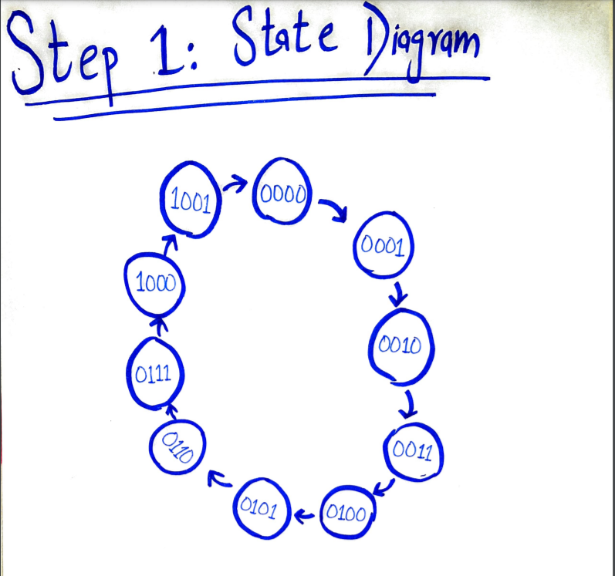

STEP 2: NEXT STATE TABLE

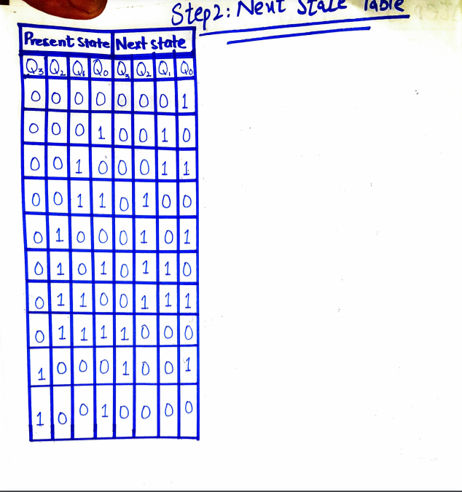

STEP3: TRANSITION TABLE

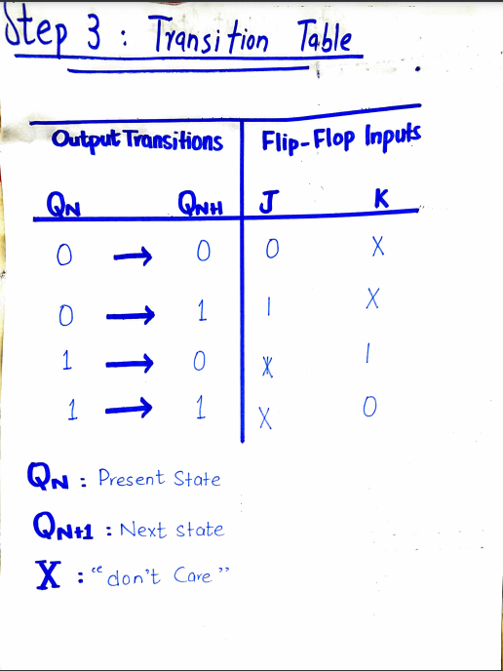

STEP 4: KARNAUGH MAP

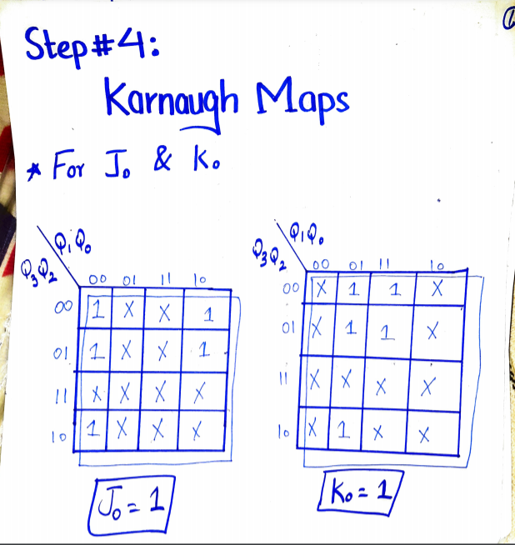

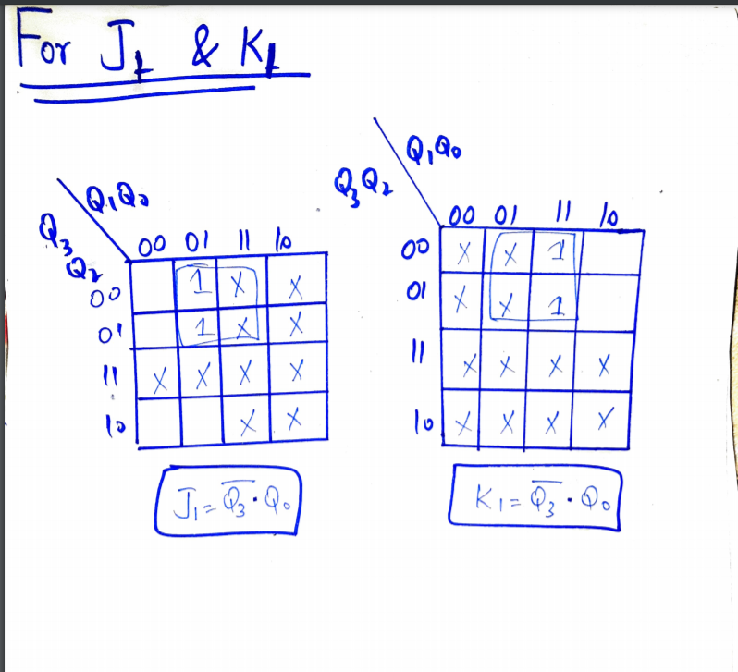

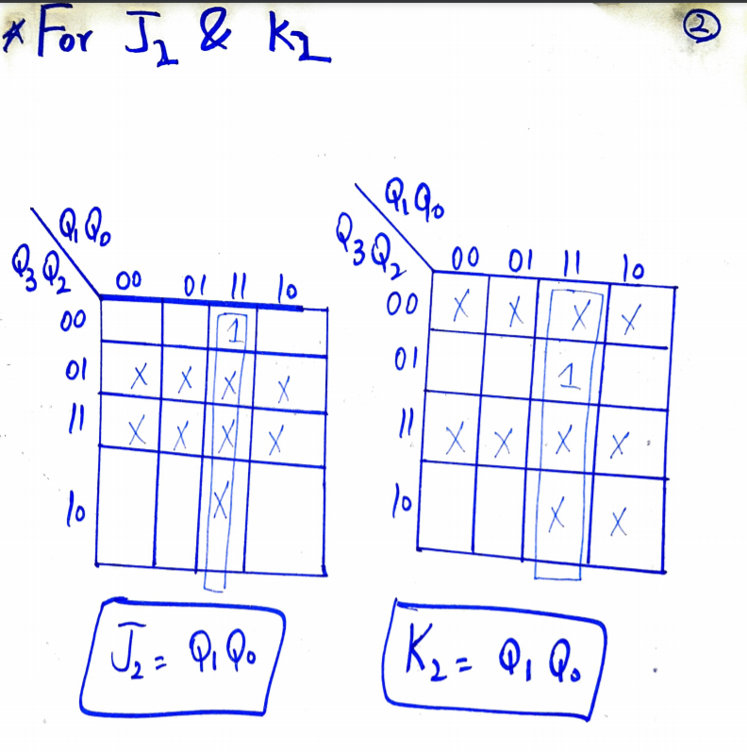

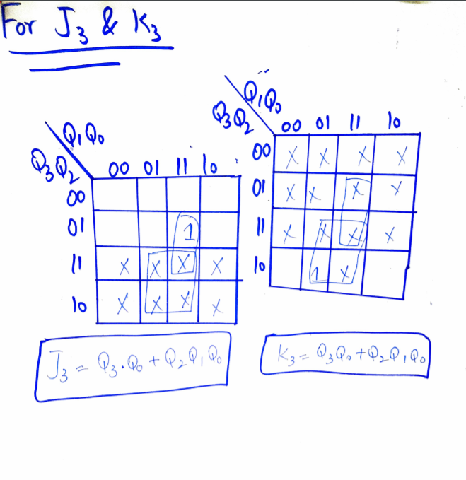

STEP 5: Circuit Diagram

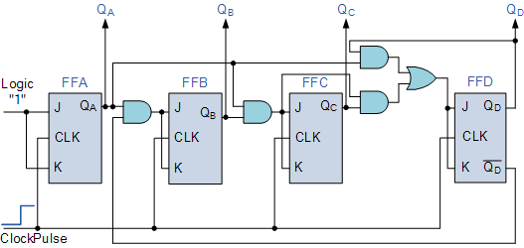

Optimization Technique:

We have used K-Map to optimize the Circuit.